Hemangini’s art gallery:

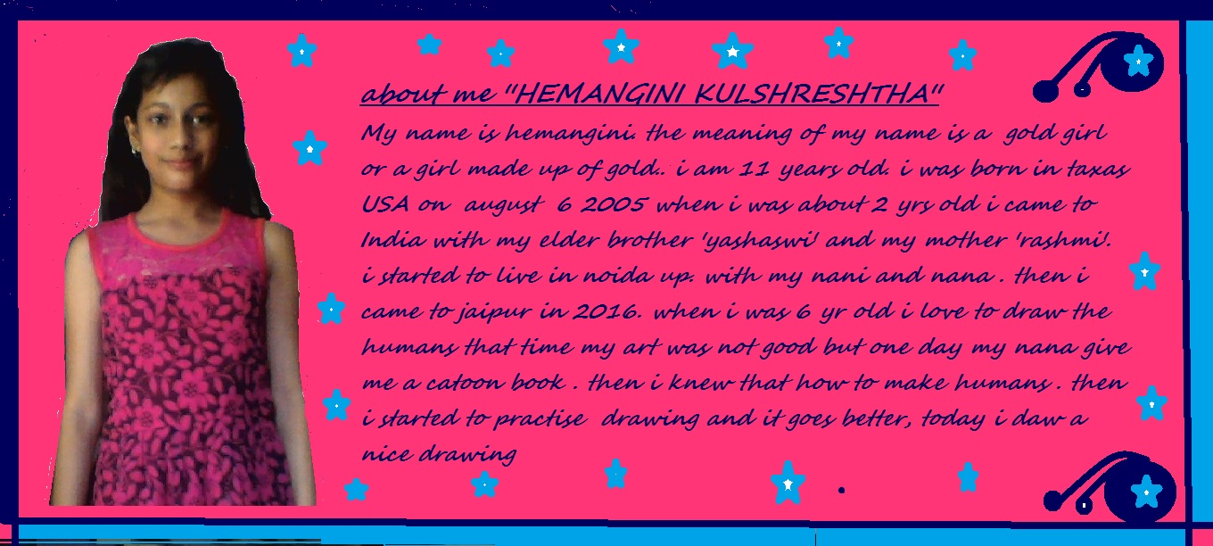

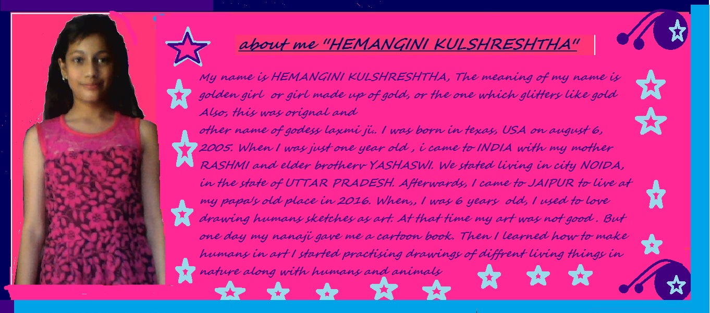

My name is Hemangini Kulshreshtha, the meaning of my name is golden girl or a girl made of gold, or the one which glitters like gold. Also, this was original and other name of Goddess Laxmi ji. I was born in Texas, USA on August 6, 2005. When I was just one year old, I came to India with my mother Rashmi and elder brother Yashaswi. We started living in the city Noida, in the state of Utter Pradesh. Afterwards, I came to Jaipur to live at my papa ji’s place in 2016. When, I was 6 years old, I used to love drawing human sketches as art. At that time my art was not good. But one day my nana ji gave me a cartoon book. Then I learned how to make humans in art. I started practicing drawing different living things in nature along with humans and my art got better. Today, I have made nice drawing showing a woman and nature around us.